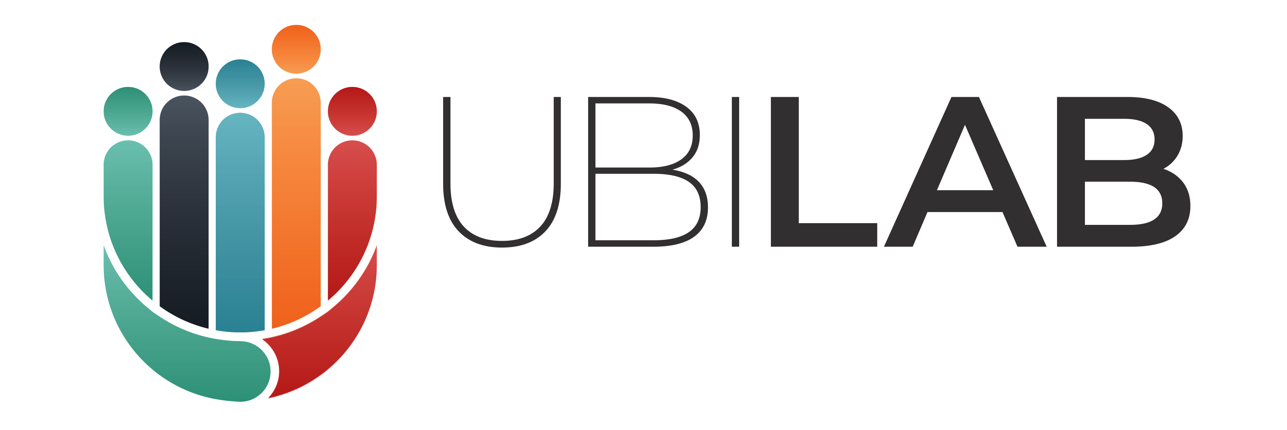
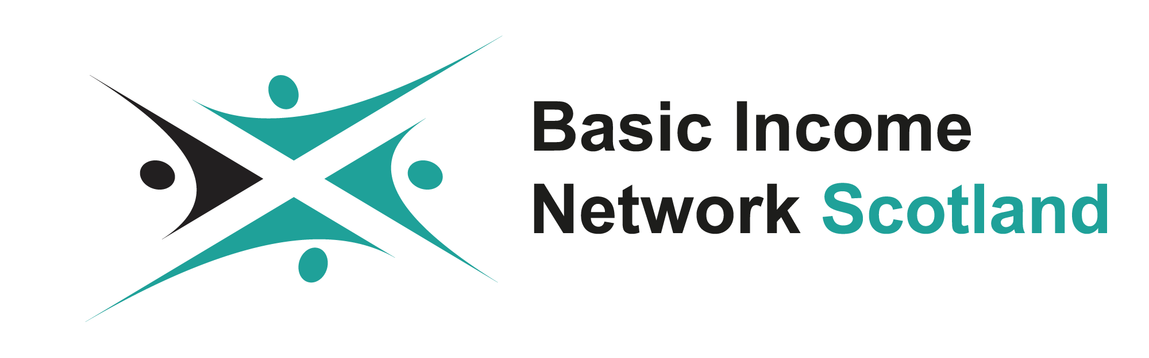

EMBARGOED UNTIL 9am, Friday 12 March 2021

Holyrood candidates asked to back Universal Basic Income pilots

Candidates in the forthcoming elections to the Scottish Parliament are being asked to sign a pledge promising to support Universal Basic Income pilots.

The pledge has been launched by Basic Income Network Scotland (BINS) in collaboration with the UBI Lab Network – both organisations which seek to explore the potential of a Basic Income for all.

The project launched at 9am on Friday 12 March and will run until the elections on 6 May. In that time, BINS and UBI Lab will contact every candidate in every seat to ask them to sign the pledge.

At the time of launch, the pledge has already been signed by candidates from most major progressive parties in Scotland.

Signatories at launch are:
- Molly Nolan, Liberal Democrat candidate for Caithness, Sutherland & Ross
- Lorna Slater, co-leader of the Scottish Greens and candidate for Lothian
- Patrick Harvie, co-leader of the Scottish Greens and candidate for Glasgow
- Matt Kerr, Scottish Labour candidate for West Scotland
- Ben Lawrie, Liberal Democrat candidate for Angus South

The project builds on the success of a similar project being undertaken by UBI Lab in Wales, where 92 Senedd candidates have signed a pledge backing UBI pilots. In England, Andy Burnham has pledged to support UBI pilots if re-elected Mayor of Greater Manchester.

14 other candidates for mayor in England have also promised to support UBI pilots.

In June 2020, the Scottish Government published the results of a £250,000 study exploring the feasibility of a Universal Basic Income pilot in Scotland.

The report found that a major pilot in Scotland would require cooperation from HMRC and the DWP, as it would involve significant changes to the tax and benefits system for participants.

The report concluded that a UBI pilot was “challenging but desirable”, and recommended that the Scottish Government move ahead with trials.

Councils in Fife, North Ayrshire and Edinburgh have all expressed a wish to pilot Universal Basic Income in their area.

In October, Glasgow City Council passed a motion calling for the city to be “front of the queue” for any future pilot.

In May 2020, First Minister Nicola Sturgeon told MSPs: “My position on that has gone from having a keen interest in exploring it to what I now describe as active support for it.”

By signing the pledge, Holyrood candidates commit to:
- Support calls to pilot Basic Income in Scotland
- Lobby Westminster for the full cooperation of HMRC and DWP needed to pilot Basic Income
- Work with other members of the Scottish Parliament to call for a new economic settlement which includes trialling a Basic Income

Over the coming months, BINS and UBI Lab will lobby the First Minister as well as other members of the Scottish Government to sign the pledge.

After the election, both groups will use the project to put pressure on the Scottish Government to move ahead with Universal Basic Income pilots.

What is UBI?

UBI is a regular and unconditional payment given to everybody regardless of their income, wealth or work. Proposals range from £50 per week for every adult to over £200 per week for every adult and child.

Supporters believe that a UBI would guarantee everyone the right to basic financial security by providing a regular income boost for millions in the UK.

They also believe that it would give people more freedom to pursue education and training later in life, start a business, or take time out to care for a loved one without facing financial penalties.

A UBI trial in Finland showed improved mental health for participants. It also found that the recipients of a UBI spent more days in employment on average compared to the control group, debunking the myth that a UBI would discourage work.

A modest UBI-like scheme already exists in Alaska, where all citizens receive an annual dividend of around $2,000 a year from the state’s oil profits.

At Easter 2020 Pope Francis wrote: "This may be the time to consider a universal basic wage." He continued: "It would ensure and concretely achieve the ideal, at once so human and so Christian, of no worker without rights.”

All UBI proposals keep Housing Benefit and disability benefits. Many UBI proposals replace Child Benefit with a more generous UBI for children.

Most UBI proposals replace some means-tested benefits like Jobseeker's Allowance and tax credits. All serious UBI proposals would make lower and middle income households better off.

Quotes

Lorna Slater, co-leader of the Scottish Greens, said:
“The Scottish Greens have long talked about how a Universal Basic Income can provide a real safety net as part of an economy that looks after our wellbeing, so we are delighted the campaign has momentum. Set at an adequate rate, it would have a potentially hugely positive impact on health, wellbeing and poverty at a time when inequalities are being exposed by the current public health crisis.”

Molly Nolan, Liberal Democrat candidate for Caithness, Sutherland and Ross, said:
“Over the last year, so many people around the country have encountered what is meant to be the Government’s safety net, only to discover it is full of holes – from the three million excluded, to those facing a Universal Credit cliff edge. Calls for a Universal Basic Income have never been louder or more relevant. As we look to put recovery first, we should be piloting UBI across Scotland to better learn how it can empower people and communities, such as those in the Far North. That’s why I’m supporting the Holyrood UBI pledge ahead of this May’s elections.”

Jack Scott, secretary of Basic Income Network Scotland, said:
“The Westminster way of doing things has consistently failed people in Scotland. The pandemic has shown that we must guarantee economic security for everybody to ensure no one falls through the cracks. A Universal Basic Income would create a safety floor which nobody could fall beneath and has true potential to transform people’s lives. The year after the creation of the NHS saw the single biggest improvement in the health and wellbeing of people in Scotland any time before or since. As we rebuild from the pandemic, a Universal Basic Income could be our generation’s NHS.”

Notes to editors

If you need more information quotes, interviews or photos, contact me at samg@weareopus.org or call me on 07814 795 361.

About Basic Income Network Scotland
Basic Income Network Scotland is a volunteer-run educational charity at the forefront of the Basic Income movement in Scotland. The organisation aims to advance research and public awareness around the economic and social effects of Basic Income. It supports a network of Basic Income advocates, hosts events as platforms for discussion, lends expertise to government, and shares the stories of people who would benefit from a Basic Income.

About UBI Lab Network
The UBI Lab Network is a worldwide network of citizens, researchers, activists and campaigners exploring the potential of Universal Basic Income. The network is working towards piloting a basic income and creating a movement for change through a large network of UBI Lab groups around the world and in UK cities and regions including Sheffield, Newcastle, Northern Ireland, Kirklees, Leeds, Liverpool, Jakarta, Bucharest, York, Birmingham and Hull.

